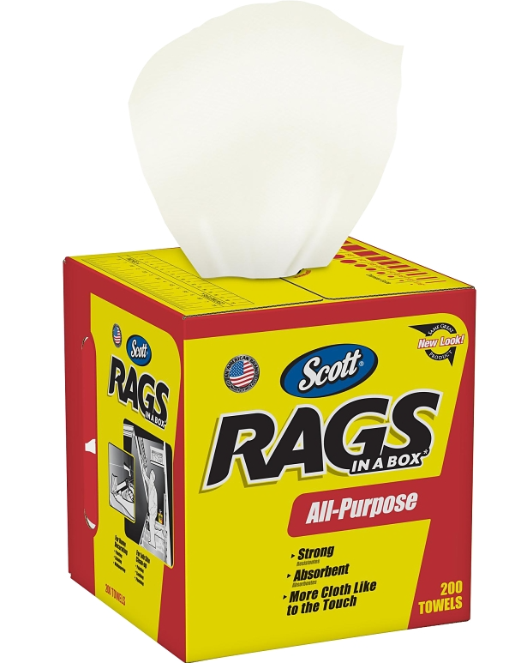

Product Details
Capacity:
200
Color:
White
Material:
Cellulose Fiber
Size:
10 x 12 in
Thickness:
1-Ply
Features
• Box of rags contains absorbent towels that feel and perform like a cloth
• Strong, durable and multi-purpose for thousands of projects like painting, polishing, detailing, spill cleanup, staining, polishing and refinishing furniture
• Designed for wet or dry-cleaning applications
• Pop-up box with built-in handle allows you to take the product to the job while keeping rags clean

